RoofScope: Automatic Roof Detection and Analysis Using Deep Learning and Computer Vision
Mohammed Abed 21903608, Tolga Yılmaz Ardor 21901918, Hande Eryılmaz 21902678

Abstract
This paper presents RoofScope, an innovative approach for automatic roof detection and analysis using deep learning and computer vision. The project focuses on accurately detecting roofs in given images through machine learning algorithms and further analyzes segmented roofs to identify edges and lines using edge and line detection techniques. To ensure comprehensive roof analysis, obstacles such as chimneys or panels are identified through blob detection algorithms. The proposed methodology is evaluated on diverse datasets, demonstrating its capability to handle varying roof geometries and challenging scenarios such as shadows or obstructions. The findings highlight the effectiveness of the framework in facilitating advanced roof detection and analysis, making it a valuable tool for applications in photovoltaic (PV) system installations.

Introduction
Solar panel installations heavily rely on roofs. Conventional roof detection techniques frequently depend on manual inspections or simplistic algorithms, which are unable to handle the complexity presented by different roof textures, shapes, and environmental elements like obstacles or shadows. For roof analysis to be accurate and scalable, a strong, automated method is required.

In order to overcome this difficulty, RoofScope automates roof recognition and analysis by combining deep learning and computer vision techniques. The technology uses machine learning algorithms to recognize roofs in images, providing a high level of accuracy in a variety of situations. Following the detection phase, the segmented roofs are evaluated for edges and lines using cutting-edge edge and line detection techniques. Accurate segmentation and precise geometric analysis of the identified roofs are ensured by this two-layered method. Blob detection algorithms are used to identify obstacles like solar panels, chimneys, or waste material in order to improve the analysis and provide a comprehensive understanding of roof structures.
RoofScope's main goals are to create a dependable system that can operate successfully in a variety of urban environments and offer useful information for planning photovoltaic (PV) systems. RoofScope hopes to open the door for more precise and efficient roof analysis by overcoming the drawbacks of current techniques, which would make a significant difference in the optimization of renewable energy.

Literature Review

Overview of Related Works
Particularly in the solar energy industry, the combination of computer vision and artificial intelligence (AI) in roof identification and analysis has attracted a lot of interest. One of the leading companies in this area, Aurora Solar, has created AI-powered solutions to automate roof structure modeling and obstacle detection. Their software streamlines the design process for photovoltaic (PV) systems by using high-definition satellite images and Light Detection and Ranging (LIDAR) data to create detailed 3D roof models in less than 15 seconds. [1]

Aurora Solar has added features like HelioScope Similar Obstruction Detection in addition to roof modeling. In commercial and industrial solar projects, this solution uses unique AI technology to effectively identify and establish exclusion zones around rooftop impediments, like vents and skylights. [2]

These developments from Aurora Solar are a prime example of how AI and computer vision can be used to automate difficult roof identification and analysis chores. Their solutions have established a standard for the sector, proving how well cutting-edge technologies can be integrated to increase precision and productivity in the design and implementation of solar projects. [3]

Comparison with Existing Methods
The capabilities of roof detection systems have been greatly enhanced by recent developments in AI and machine learning. With their AI-powered solutions that combine LIDAR data and high-resolution satellite imagery to automate obstruction detection and roof modeling, companies such as Aurora Solar have set standards. The time needed for processes like PV system design is greatly decreased by their systems' excellent accuracy and efficiency. These technologies are less accessible for wider use cases, though, because they are mostly focused on solar energy applications and frequently require costly datasets, like LIDAR, despite their improvements.

To overcome the shortcomings of current approaches, RoofScope presents a thorough framework that blends computer vision and deep learning techniques. RoofScope seeks to get comparable precision utilizing more widely available datasets, improving scalability and affordability, in contrast to Aurora Solar, which mostly depends on specialized data sources like LIDAR. In order to provide a comprehensive approach to roof analysis, RoofScope also expands its capabilities by using blob identification techniques to locate rooftop obstructions. Existing systems are excellent at automating particular activities, but RoofScope places more of an emphasis on adaptation and flexibility, which makes it appropriate for a larger range of applications, such as renewable energy optimization.

Methodology
The RoofScope framework employs a two-step approach: roof detection using deep learning and roof analysis with computer vision. First, roofs are segmented from images using a trained machine learning model. Then, the segmented roofs are analyzed to detect edges and lines using edge detection algorithms, and obstacles are identified using blob detection. This approach ensures accurate and adaptable roof detection and analysis for diverse scenarios.

Machine Learning for Roof Detection

Dataset Preparation
The "Aerial Images of Rooftops with Labels" dataset from Kaggle, consisting of 1670 images and corresponding masks is used for this project. The aerial photos are located in the "images" directory, while ground-level truth masks are located in the "labels" directory. [4] The dataset was partitioned into training (52.5%), validation (22.5%), and testing (25%) subset to guarantee efficient model training and evaluation. This layered split preserves the distribution of building sizes and densities across all groupings.

Model Selection and Training
Semantic segmentation plays a crucial role in this project by extracting the roofs in satellite images for further analysis, such as edge and obstacle detection. i U-Net deep learning architecture was utilized, known for its effectiveness in biomedical image segmentation and recently in remote sensing applications. The U-Net, depicted in Fig.1, has an encoder-decode design with skip connections [5].

The U-Net variant used in our project has two key components:

- Contracting Path (Encoder): involves repeated double 3x3 convolutions with rectified linear unit (ReLU) activations, followed by 2x2 max-pooling layers for downsampling, enabling the extraction of high-level spatial features while progressively reducing the dimension.
- Expansive Path (Decoder): it applies sampling layers followed by 2x2 up-convolutions. Skip connections are integrated at each stage, connecting corresponding encoder layers to restore spatial details. Each step also includes double 33x3 convolutions and ReLU activation functions, finally a 1x1 convolutional layer is applied to output the segmentation masks

Some of the training parameters:
- Loss function: Binary cross-entropy
- Optimizer: Adam optimizer
- Learning rate: 0.001
- Batch size: 16
- Number of epochs: 15
- Environment: Google Colab’s T4 GPU

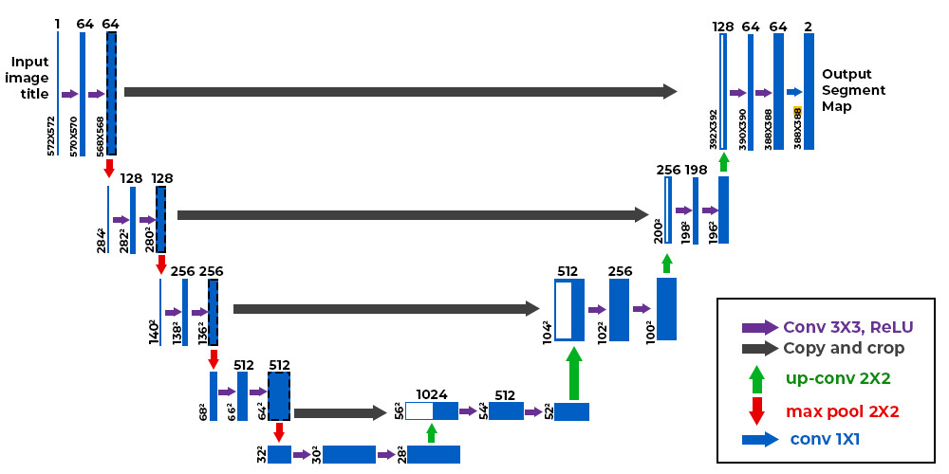
Fig. 1 : U-Net Structure [6]

The training and the validation loose over epochs can be seen in Fig. 2. The validation loss decreases alongside the training loss but at points, it decreases even more sharply below the training loss, promoting a deeper analysis.
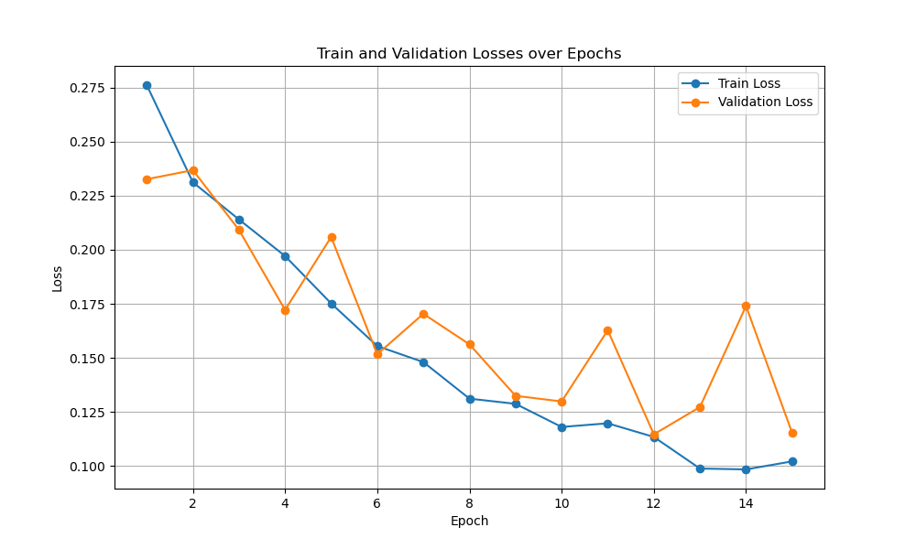
Fig. 2: Train and Validation Losses over Epochs

Results and Performance

The trained U-Net model demonstrated descent results in segmenting roofs from satellite images, as seen by the sample outputs from the testing data in Fig.2-4.

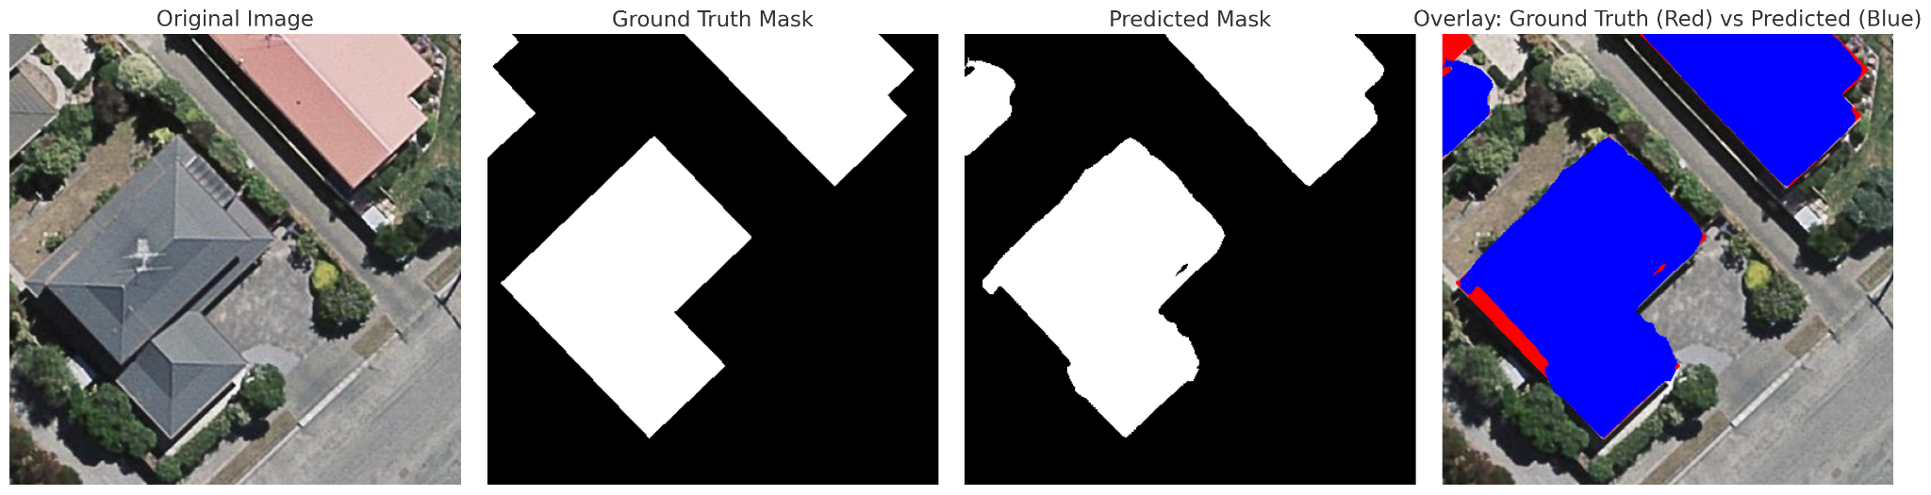
Fig. 3: Image(1) vs. Ground Truth vs. Predicted Mask

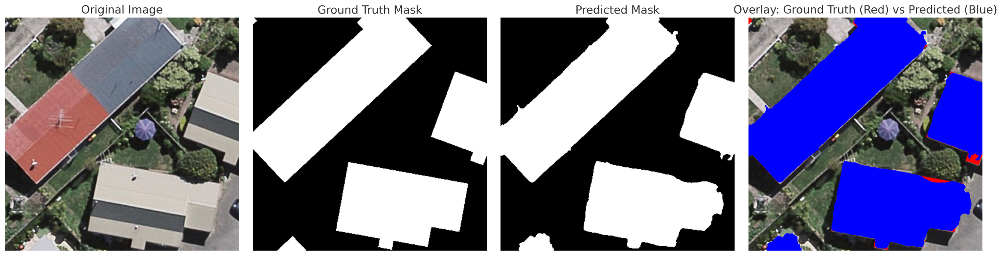
Fig. 4: Image(2) vs. Ground Truth vs. Predicted Mask

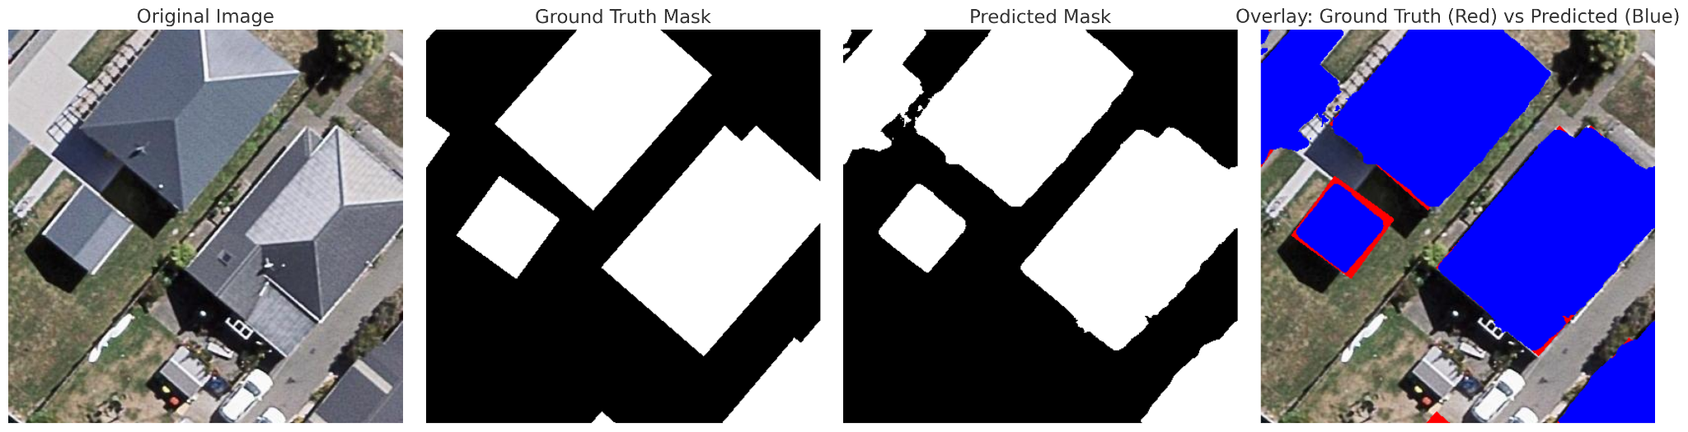
Fig. 5: Image(3) vs. Ground Truth vs. Predicted Mask

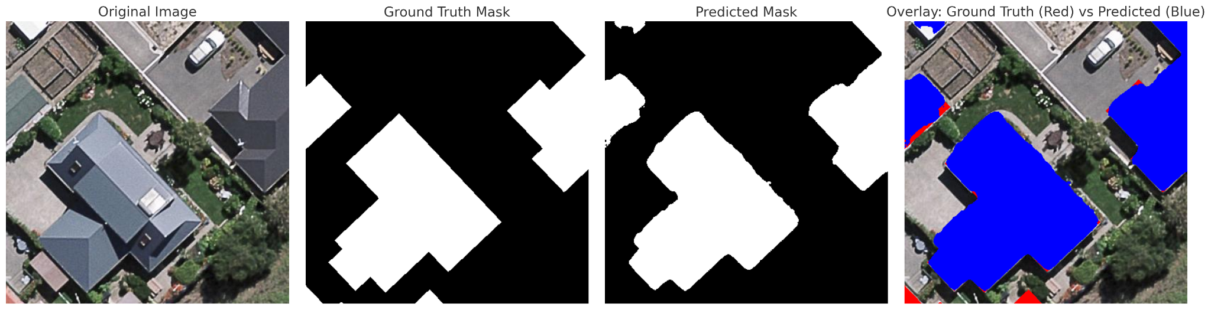
Fig. 6: Image(3) vs. Ground Truth vs. Predicted Mask

The evaluation metrics used were:
- Pixel-wise Accuracy: measure the proportion of correctly classified pixels to ground truth.
- Intersection over Union (IoU): evaluates overlap between predicted and ground truth masks.

The plot seen in Fig. 7 highlights the metrics results calculated over batches of size 8. The average accuracy over the test set is 97.65%, and the average IoU on the test set is 88.86%.

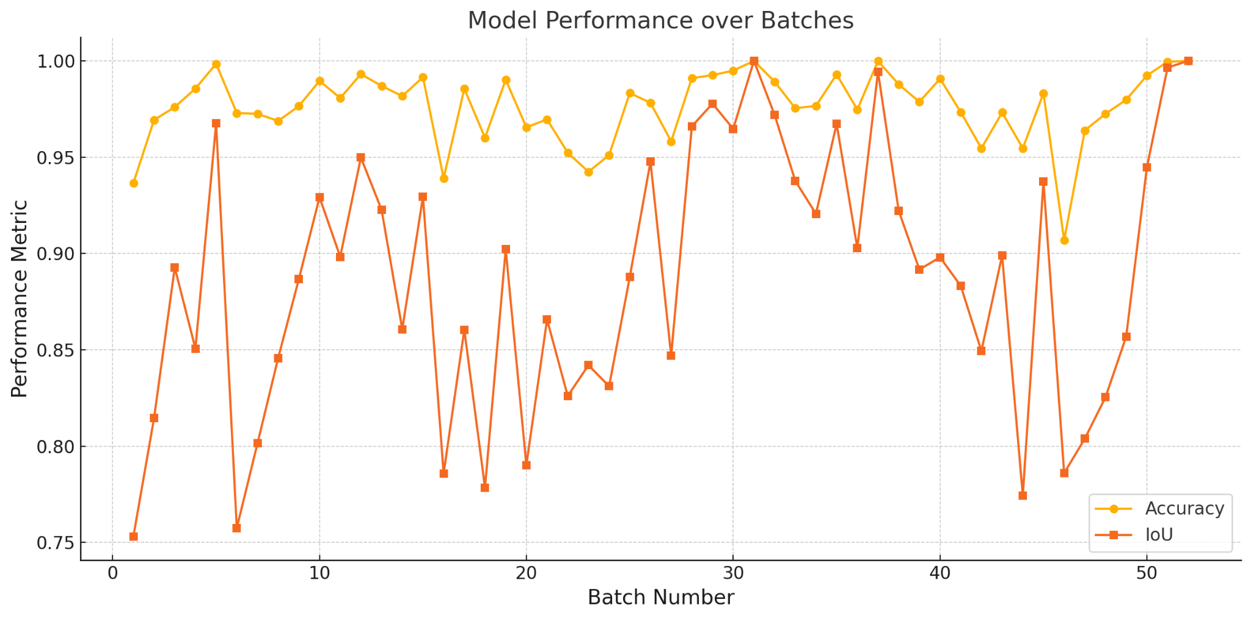
Fig. 7: Model Performance Over Batches

The next step was to extract the roofs given their predicted masks to facilitate further processing. A sample output can be seen in Fig. 8.

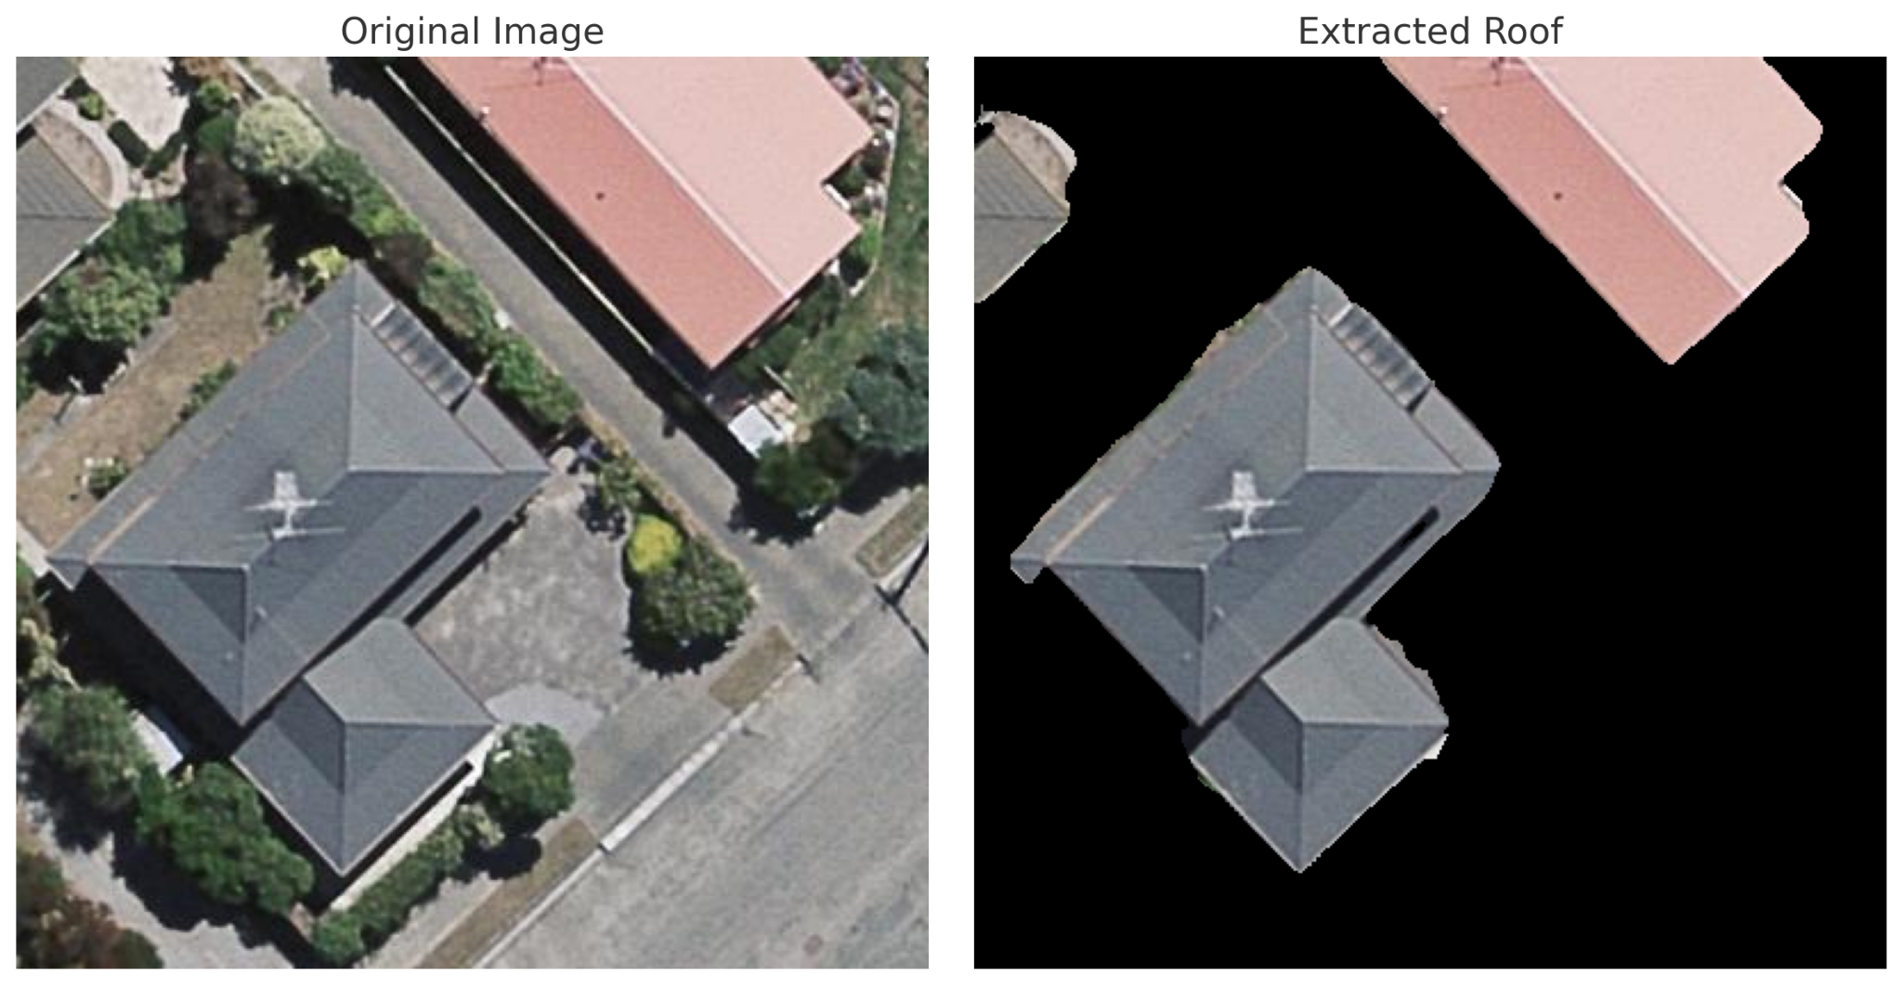
Fig. 8: Original Image(1) and the Extracted Roofs

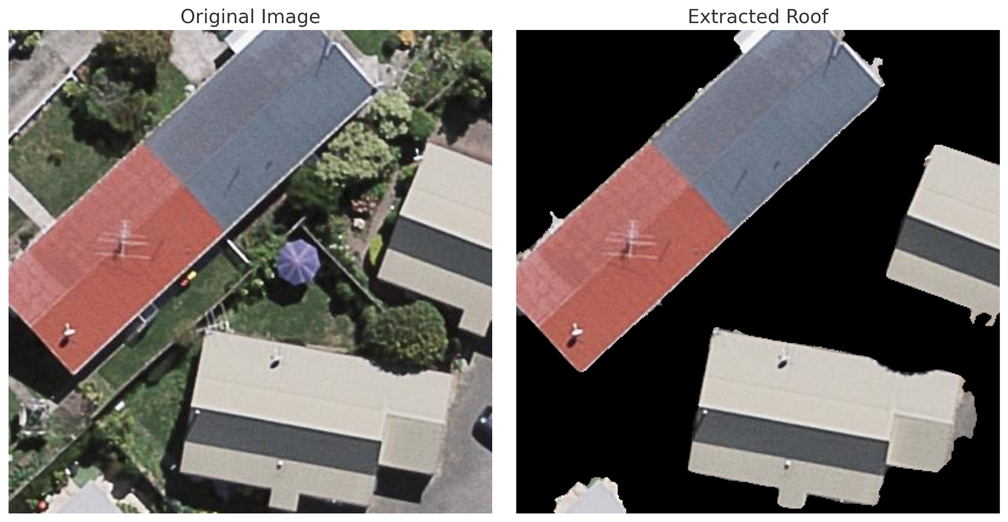
Fig. 8: Original Image(2) and the Extracted Roofs

Computer Vision for Roof Edge and Line Detection
Using computer vision techniques, RoofScope's roof edge and line detection process examines the segmented roof regions and extracts geometric features. In order to detect visible edges and contours, edge detection techniques are applied after the roof images have been preprocessed to improve edge clarity. These identified boundaries are crucial for understanding the roof's architecture and structure, which makes further analysis and decision-making easier.

Image Preprocessing
To prepare the roof images for edge detection, several preprocessing steps were applied to enhance the clarity and visibility of edges. These steps ensured that the edge detection algorithm operated effectively on the input images:
- Grayscale Conversion: The original images, typically in RGB format, were converted to grayscale to simplify processing while preserving structural details.
- Gaussian Blurring: A Gaussian blur with a kernel size of 5 \times 5 was applied to reduce noise and smooth the image. This step helps suppress unnecessary details and enhances the detection of prominent edges.

These preprocessing steps ensured that the input images were optimized for accurate and efficient edge detection, even in the presence of noise or complex roof textures.

Edge and Line Detection Algorithms
Visible edges were extracted from the preprocessed roof photos using the Canny edge detection technique for edge and line detection. The approach uses a multi-step process that includes edge tracing using hysteresis, gradient calculation, and non-maximum suppression.

- Gradient Calculation
The Canny algorithm computes the intensity gradients of the grayscale image using Sobel filters in both horizontal (Gx) and vertical (Gy) directions. The gradient magnitude (G) and direction (θ) are calculated as:

$G = \sqrt{G_{x}^{2}+G_{y}^{2} } , θ = \tan^{-1}(\frac{G_{y}}{G_{x}})$ (1)

This step highlights areas with rapid intensity changes, which typically correspond to edges.

- Gaussian Blurring
Before gradient calculation, the image undergoes Gaussian blurring to reduce noise. This smooths out small variations, ensuring that only significant edges are detected.

- Non-Maximum Suppression
The algorithm retains only the local maxima in the gradient magnitude image along the gradient direction. This step refines the edge map by suppressing non-edge pixels.

- Hysteresis Thresholding
Two thresholds are used: a low threshold (50) and a high threshold (150). Pixels with gradient magnitudes above the high threshold are classified as edges, while those below the low threshold are discarded. Pixels with values between the thresholds are included only if they are connected to a strong edge.

- Contour Detection
The edges detected by the Canny algorithm are then passed to the contour function to identify closed contours in the image. These contours represent the roof edges and other structural lines.

Computer Vision for Roof Obstacle Detection
Roof Scope’s roof obstacle identification phase uses MSER (Minimally Stable Extremal Regions) to locate important rooftop features like solar panels, chimneys, and other structural components. This technique tries to find obstacles of all sizes and forms and lighting situations were tried to be detected by concentrating on stable intensity-based zones. The system can adjust to various rooftop textures and lighting conditions by parameter adjustment, which improves accuracy and dependability

Algorithm Description
The improved obstacle detection algorithm employs OpenCV’s MSER feature extractor to find extremal regions that stand out due to their intensity characteristics. Once these stable regions are identified, they are analyzed based on their geometric and intensity properties to confirm their relevance as rooftop obstacles. Adjusting parameters such as size constraints and intensity thresholds enables the algorithm to achieve optimal detection performance under diverse conditions.

- Intensity-Based Obstacle Extraction

MSER identifies stable extremal regions by varying the intensity threshold. Consider a connected set of pixels Q at intensity threshold t. When the threshold is slightly modified by Δ, a new region $Q_{t+Δ}$​ is extracted. Stability is determined by how much the region’s size changes under this intensity variation:
$δ\left(Q\right)=\frac{\left|Q_{t+Δ}\right|-\left|Q\right|}{\left|Q\right|}$
Regions with minimal $δ\left(Q\right)$ over a range of thresholds are considered stable extremal regions.

- Stability Criterion
Regions must maintain their shape and size within defined intensity bounds for MSERs. For each region, if the average intensity remains relatively consistent as the threshold changes, the region is stable. This stability ensures detection despite variations in lighting:
$δ \left(Q\right)→MSER candidate.$.
- Geometric and Intensity-Based Filters
Once MSERs are extracted, geometric and intensity criteria are applied to results:
- Aspect Ratio (AR):

$AR=width/height$
By sustaining the AR in a reasonable range ensures the miss detections
- Intensity Uniformity
By inspecting variance among the pixels, if the variance is low in a region, it ensures uniformity in the region.Therefore, the regions with low variance are retained.

- Optimal Parameter Selection
To increase the number of valid recognized regions, the algorithm repeatedly tried various MSER parameters, including minimum area, maximum area, and stability thresholds.
- Visualisation
Once the optimal parameters are identified, the blobs are drawn on the input image using the cv2.drawKeypoints function. This step provides a clear visualization of the detected obstacles.

Parameter Tuning
Parameter tuning is a critical step in optimizing the blob detection algorithm for accurate and robust obstacle detection. In this project, an iterative grid search approach was used to identify the best combination of parameters for the MSER parameters. Each parameter was systematically varied within predefined ranges, and the performance of the detector was evaluated based on the number of detected key points that met the filtering criteria..
- Parameter Ranges
- $Delta\left(δ\right):\left[2,5,10\right]$
- $Minimum Area\left(A_{min}​\right):[20, 50, 100]$
- $Maximum Area (A_{max}​): [200, 500, 1000]$
- $Maximum Variation ({σ^{2}}_{max}​): [0.1, 0.3, 0.5]$
- $Minimum Diversity ({Div}_{min}​): [0.1, 0.3, 0.5]$
- Grid Search Process
For each combination of the above parameters:
- An MSER detector was configured with the current parameter set.
- The detector processed the input image, extracting stable extremal regions.
- Regions that passed all filtering steps (e.g., geometric and intensity criteria) were counted.
The scoring function (S) for each parameter set was defined as:
$S= Number of valid MSER regions detected$
The parameter combination that yielded the highest S was selected as the optimal parameter set
- Optimal Parameters
- $Delta\left(δ\right)=5$
- $Minimum Area\left(A_{min}​\right)= 50$
- $Maximum Area (A_{max}​)=500$
- $Maximum Variation ({σ^{2}}_{max}​)=0.3$
- $Minimum Diversity ({Div}_{min}​)=0.3$

Experiments and Results

Analysis of Results

The overall results are meaningful; we could successfully apply most of the methods and processes that we learned in the lecture. The part that needs to be improved is the object detection. If we perform another model for object (obstacle) detection and train a model for chimneys and solar panel datasets, that could increase the overall accuracy as well.

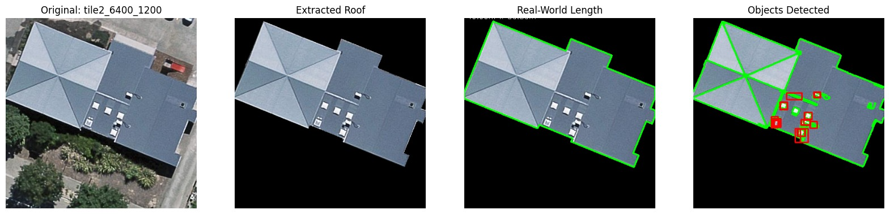
Fig. 9: Outputs of Original Image “tile2_6400_1200”

- Moreover, we observed that the obstacle detection based on intensity detects shadows and balconies as obstacles as well. Here in the below Figure 10, in the obstacle detection image’s left corner, we saw a big red circle indicating an obstacle detected. However, in the original image, there are no obstacles. There is just a shadow.

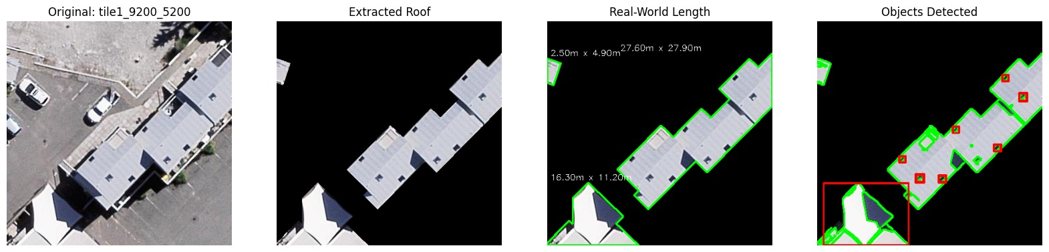
Fig. 10: Outputs of Original Image “tile1_9200_5200”

Also, another result is that ifan image contains multiple roofs, it sometimes detect obstacles for most of them and misses some for example in the following Figure 11, there are couple water pipes on the right upper roof and it misses them.
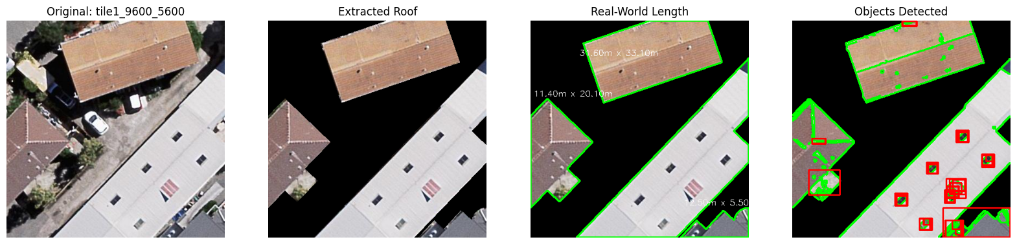
Fig. 11: Outputs of Original Image “tile1_9600_5600”

Overall, this project enabled us to implement all of the content that we learned in the class such as preprocessing steps of resizing, smoothing, sharpening, Canny edge detection, PCA for features, line fitting to find line segments, implementation of Neural Network in U-Model.

Challenges Faced

The U-Net model struggled with precise segmentation at the boundaries resulting in less sharper edges due to over-segmentation and under-segmentation. Moreover, shadows, trees, and nearby objects caused false positives and misclassifications in some of the testing outputs. Another major issue was the dependency of the model on the accuracy of the ground truth masks, which had some errors. This negatively impacted the model training and evaluation.

One of the most time-consuming and challenging parts was preprocessing. Because the images were satellite images with low quality to improve our edge detections and line fittings, we implemented all the preprocessed steps that we learned in the class such as resizing, smoothing, sharpening, etc. However, still we have not reached a good quality of images to perform our obstacle detection.

In the object detection part, the challenge was to minimize the effects of shadows or color deformations on the roofs such as rust, faded colors on the roofs. Because the object detection finds the possible areas according to intensity so it was a hard challenge to minimize the effects of these.

Limitations of the Approach
The training dataset was not very diverse; data augmentation techniques (rotation scaling, and color jittering) could have been applied to make the model capable of generalizing given the size and the quality of the data. Furthermore, the images have low quality; therefore, while line fitting for finding the line segments, it gave low accuracy. Moreover, the limitations of what we learned to detect objects in our classes are not robust enough to get high accuracy. Resulting in different optimal parameters for each image. This can be solved by training another model specified object detection to detect solar panels, chimneys, etc. from satellite images.

Conclusion
The RoofScope project successfully demonstrated the integration of deep learning and computer vision for automated roof detection and analysis. By utilizing the U-Net model, the project achieved precise segmentation of roofs from satellite images, with average pixel-wise accuracy and Intersection over Union (IoU) scores of 97.65% and 88.86%, respectively. The segmentation masks provided a reliable foundation for subsequent analysis.

The computer vision techniques employed for edge and line detection effectively captured the geometric structure of the segmented roofs. The use of preprocessing steps like Gaussian blurring and the Canny edge detection algorithm ensured robust performance, even in noisy or low-quality images. Contour detection further enhanced the understanding of roof layouts.

For obstacle detection, the MSER-based approach with the best possible parameters tried to find by trial and error, which we mostly identified obstacles, including chimneys and solar panels. By refining parameters such as minimum and maximum area, intensity variation thresholds, and stability criteria, the method demonstrated improved adaptability and robustness. As a result, it consistently delivered accurate detections across varied rooftop geometries and lighting conditions, underscoring its suitability for real-world applications. But still for every image there is more optimal parameters for obstacle detection. It can be further improved with specilized CNN model.

Overall, the findings highlight the potential of RoofScope to serve as a scalable and adaptable tool for applications like photovoltaic (PV) system planning, urban analysis, and architectural design, providing a reliable and automated solution for roof detection and analysis challenges.

References
- “Aurora AI in Design Mode,” Aurora Solar Help Center, Oct. 08, 2024. https://help.aurorasolar.com/hc/en-us/articles/8172307851411-Aurora-AI-in-Design-Mode (accessed Dec. 05, 2024).
- ‌]S. Staff, “Aurora Solar debuts Helioscope Similar Obstruction Detection feature,” Solar Builder Magazine, Aug. 27, 2024. https://solarbuildermag.com/news/aurora-solar-debuts-helioscope-similar-obstruction-detection-feature/ (accessed Dec. 05, 2024).
- “Aurora Solar develops AI-driven ‘keepout’ detection program for C&I projects - Solar Industry News,” Solar Industry News, Aug. 27, 2024. https://solarindustrynews.com/aurora-solar-develops-ai-driven-keepout-detection-program-for-ci-projects/ (accessed Dec. 05, 2024).
- killa92, “Rooftop Images Segmentation | PyTorch | DeepLabV3+,” Kaggle.com, Jan. 12, 2024. https://www.kaggle.com/code/killa92/rooftop-images-segmentation-pytorch-deeplabv3/input (accessed Dec. 05, 2024).
- O. Ronneberger, P. Fischer, and T. Brox, “U-Net: Convolutional Networks for Biomedical Image Segmentation,” Lecture Notes in Computer Science, vol. 9351, pp. 234–241, 2015, doi: https://doi.org/10.1007/978-3-319-24574-4_28.
- “U-Net Architecture Explained,” GeeksforGeeks, Jun. 08, 2023. https://www.geeksforgeeks.org/u-net-architecture-explained/

